AMERICAN CIVIL WAR
Cavalry Bugle Signals FOR NON-BUGLERS
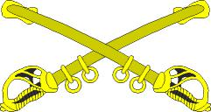

WRITTEN WITH THE CAVALRY RE-ENACTOR IN MIND

GIVING

A L L T H E C A L L S F O R C A M P A N D F I E L D D U TY

COMPLETE
DEFINITIONS AND USAGE FOR EVERY SIGNAL

TO WHICH IS ADDED
MEMORIZATION DITTIES FOR EVERY CALL

BY RICHARD D. LYNCH

CAPTAIN, 1ST NEW HAMPSHIRE CAVALRY

EDITED BY R. J. SAMP

2 N D W I S C O N S I N V O L U N T E E R I N F A N T R Y

CALIFORNIA:

PUBLISHED BY THE ARMY OF THE PACIFIC PRESS

DOM DAL BELLO, AOP BVT. COLONEL

1 9 9 9 .
FORWARD!

Nothing stirs the emotion of the cavalryman more than the sound of a bugle signaling the "Charge." Signaling the troops by the use of a horn goes back to the Roman empire. The daily routine of the American Civil war soldier was regulated by bugle signals, with the infantry, artillery and cavalry all having their own signals. Although the rank of bugler has disappeared from the modern army and the bugle is a symbol of an era gone by, bugling is a tradition that continues to live on for ceremonies and special occasions.

As reenactors we constantly strive to improve upon our impression. If this work helps to assist the cavalry reenactor with a better understanding of the bugle, its proper use in reenacting and its importance in communicating commands by signals, then our objective has been met.

R. Lynch
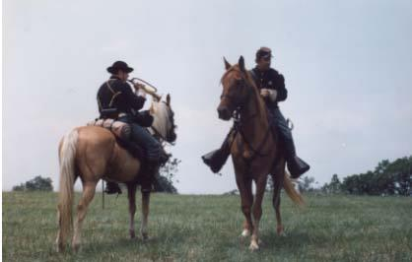

2
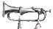U.S. CAVALRY BUGLE SIGNALS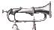 WITH DEFINITIONS: 1841-1867

Numbered as per Cavalry Tactics, (J. R. Poinsett's, 1841 Manual, Third Part.)

- The General

Signal to pack up and break camp. Thirty minutes later you will hear, boots and saddles, fifteen minutes later assembly, and in another fifteen minutes march. note: In the recently published book, "The Diary of a Bugler" by George Sargent, he indicates that while on campaign boots and saddles has the same effect as the General, only with more immediacy.

- Boots & Saddles

When a regiment is to mount, boots and saddles is sounded; at this signal the horses are saddled, bridled and prepared to be led out. First Part, P. 7
[note: Many sources confirm that in actual practice, boots and saddles was used to saddle, pack, bridle, and mount with utmost speed.]

- To Horse

At the signal to horse, the 1st. Sergeants direct the men to lead out. The Sergeants, Corporals, and Privates, being in two ranks, in the order of their platoons, at the head of their horses, the Orderly Sergeant calls the roll. In case of alarm or surprise, to horse is sounded; the men then saddle, pack up, bridle and mount with the utmost celerity and repair to the place of assembly, which is always previously designated. First Part, P. 8 [when acting as dismounted skirmishers, return to the # 4 individual & horseholder.]

- Assembly

The trumpeters sound the assembly for troops to form-rank for Roll Call without weapons and for marching the squadrons to the parade.

- To Arms

When a regiment is to turn out under arms on foot, "to arms" will be sounded; at this signal, the men are formed and inspected and the reports are made as is prescribed. First Part, P. 8 [signal of "alarm" while on campaign.]

- To The Standard

As soon as the standard appears, the Captain orders the sabres to be presented; the trumpets sound to the standard. First Part, P. 10 [also sounded at head of column to prepare for action.]

- March

After "to the standard" has been twice repeated, the Captain orders the sabres to be carried, and breaks in the same order in which he came; the trumpets sound the "march." First Part, P. 10 [to move forward at the walk.]

3

U.S. CAVALRY BUGLE SIGNALS WITH DEFINITIONS: 1841-1867

- The Charge

Keeping the horses straight, charge as directed: The charge in line is executed by the squadron when in line; it should be as short as possible, so as to arrive in good order, and without fatiguing the horses. The charge in column is executed by the squadron broken with distance. To execute the charge as foragers, all the troopers of the squadron disperse, and direct themselves each upon the point he wishes to attack, observing not to lose sight of their officers, who charge with them. The squadron being in line, the first captain orders the sabres to be drawn, and the platoons to charge one after another, commencing by the right. For this purpose the first Captain advances 240 paces to the front, taking a trumpeter with him; and when he wishes the movement to commence, he causes a signal to be given. The platoon moves forward at the command of its chief, as prescribed, No. 569. It passes successively from the walk to the trot, and from the trot to the gallop, and from the gallop to the charge. Second Part, P. 262-3.

- Rally

When the squadron is dispersed as foragers, the first Captain causes the rally to be sounded. In rallying, the troopers direct themselves to the right and to the left, outside of the flanks of the squadron in order to unmask promptly the front of the squadron, and to reform in passing by the rear. Second Part, P. 267.

- Reveille

Morning Roll Call. Signals the beginning of the morning roll call count. note: This is not the signal to awaken. "Assembly of Buglers # 16 is that signal.

11) | Stable Call | Feed and groom horses.
12) | Watering Call | Water horses.
13) | Breakfast | Time for breakfast.

- Assembly Of Guard Posting of guards/pickets. Change of guard every 24 hours.

- Orders

Time to receive orders. NCO's report to commander. Roll call and Daily reports are submitted to the Adjutant.

- Assembly Of Buglers

It is played first thing in the morning and called "First Call.". It is the signal to awaken. The signal is for all buglers to assemble.

4

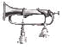
U.S. CAVALRY BUGLE SIGNALS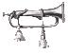 WITH DEFINITIONS: 1841-1867

17) Retreat (short version) Retreating while continuing to fire. *

(long version) Evening colors ceremony. (flag lowering)

- #17. Retreat. At the signal retreat, the troopers of the first rank move forward 5 paces, fire, then turn to :the left-about, in order to move to the rear; and retire loading their pieces. When they have marched 50 paces, or more if necessary, the chief of platoon
causes the about, No.5 to be sounded. At this signal, the troopers, who were retiring,

face to the front by turning to the right-about. The troopers who are in the first line fire and turn to the left-about, retire in loading their pieces, pass in the intervals of the line which is the rear, move 50 paces farther, and face to the front at the signal the about, No.5. The troopers of the line which is in rear, move 5 paces to the front the moment the troopers who retire pass into their intervals; they then commence firing by the flank indicated. The alternate movement of the two lines continues as long as the skirmishers move to the rear. To halt the retreat, the chief of platoon orders forward, No.1, to be sounded. The skirmishers who are in rear move up, in doubling the gait, abreast of those the most advanced, and all march forward until the signal, to halt, No.2 is sounded. If the whole line of skirmishers is to retire at once, he orders the about, No.5 to be sounded. The reserve retires and faces to the front, regulating its movement by that of the skirmishers, so as to remain always at 60 paces from the 2d line. It executes its rear movement at the moment the retreating line passes into the intervals of the line which moves forward. Second Part, P .178

18) | Fatigue Call | Assemble for work details-wood, water, cook, police, etc.
19) | Dinner Call | Time for dinner.
20) | Distributions | Pay, mail, provisions, etc.
21) | Drill Call | Fall in line and dress ranks for drill.
22) | Officers Call | Officers meeting at Headquarters.
23) | Common Step | Ceremonial pass in review and marching tune.
24) | Cease Firing | Stop firing.

- Officers Take Place Officers are behind the firing line and return to their battle lines after firing. Used to reform ranks after battle.

- Sick Call Bring the sick to the Medical Staff for examination.

- TattooLights out. As a trio this is used for returning the men to camp.

5

U.S. CAVALRY BUGLE SIGNALS For the Service Of Skirmishers
WITH DEFINITIONS: 1841-1867

With respect to the signals, as well as to commence firing and to cease firing, the troops conform to what is prescribed in the school of the platoon mounted and PL 52 Fig. C. Second Part P. 268. The chief of the platoon, followed by his Trumpeter, places himself half way between the skirmishers and the reserve; he moves along the line wherever he thinks his presence most necessary. Second Part, P. 177. The same signals are also used for dismounted cavalry as well.

- Forward

If the chief of the platoon wishes the skirmishers to move forward, he causes the forward, No.1, to be sounded; each skirmisher moves forward, regulating his movements by those of the guide and preserving his interval; the reserve follows them, keeping at its proper distance. Second Part, P.177.

- Halt

The commander causes the halt to be sounded when the skirmishers are a 100 to 150 paces from the reserve. Second Part, P. 176. Brings troops to a stop.

- To The Left

Left turn 1/4 of a circle. To move the skirmishers towards the left, to the left, No.3 is sounded; each skirmisher turns to the left and marches in the new direction of those who precede him, taking care to preserve his distance. The reserve also turns to the left. To face the skirmishers again to the front, to the right, No.4 is sounded; the skirmishers and the reserve turn to the right. Second Part, P. 177.

4) To The Right Right turn 1/4 of a circle.

- About

If, after having turned to the right, the instructor wishes the skirmishers to move towards the opposite side, [rear] he orders the about, No.5, to be sounded; the skirmishers and the reserve turn to the left-about, and move forward. If after having turned to the left, the instructor wishes the skirmishers to move towards the opposite side, [rear] he causes, the about, No.5, to be sounded; the skirmishers and the reserve turn to the right-about, and move forward. Second Part, P.177.

- Rally On Chief

When the squadron is dispersed as foragers, the first Captain should sometimes establish himself to the right or to the left of the direction followed by the troopers, and then order the rally to be sounded to accustom them to rally upon any point he may select. Second Part, P. 268. At this signal, each platoon rallies as rapidly as possible upon its chief Second Part, P. 271.

- Trot200 to 220 paces per/min. over a 1000 pace distance. Second Part, P. 197.

6

U.S. CAVALRY BUGLE SIGNALS For the Service Of Skirmishers
WITH DEFINITIONS: 1841-1867

- Gallop

300 paces per/min. over a 1000 pace distance. Second Part, P. 197. A horse gallops true when he gallops on the right foot, in exercising or turning to the right hand, and on the left foot, in exercising or turning on the left hand. Second Part, P. 74.

- Commence FiringDischarge weapon. Continue until ordered to cease fire.

- Disperse

At the signal to disperse, the squadron disperses in every direction to the front. Second Part, P. 267.

_______________________________________________________________

The “MUST KNOW” CAVALRY Bugle Signals

For American Civil War Cavalry Reenactors

The following 15 bugle signals are a condensed list of calls that are absolutely necessary for you to correctly pull off an American Civil War Cavalry impression. You not only must know the signal and what it means, but you must react appropriately and instantaneously when you hear the call. Memorization ‘ditties’ to help you sing and learn the tunes are provided later on. Numbering is per Poinsett's

2.-Boots and Saddles Go to your horses bridle and saddle 'em up

8.-CHARGE!!
4.-Assembly means form up, including on the battlefield
9.-Rally (fall back quickly to your reserves)
10.-Disperse we do not want the troops bunched lip, lie down, take cover, spread out
11.-Stable Call is very important, care of the livestock comes first (Water Call One hour later)
15.-0rders {NCO's and Adjutants ONLY}
16.-Assembly of the Buglers is important to wake the troops up
17.-Retreat the first measures as a signal mean ‘Fall Back!’. Complete call is Flag Lowering.
22.-Officers Call |  | {Officers ONLY}
24.-Cease Firing
S 1.-Forward | (March)
S 2.-Halt | (stop)
S 5.-About | (Turn Around)
S 9.-Commence Firing
Inf. Recall | to get the troops back to the camp, return from detached duty/sutlers, dismissal
 | from drill
Your Unit's Signal(s)

7

Other Bugle Signals of Importance to Cavalry

Unit Call

A call composed by the unit bugler that is unique and unlike any other call and is used to signal that the next signal is for your unit only. Used by the chief bugler to order specific maneuver elements to respond to a particular signal. Platoon and company calls may also be developed in addition to the regimental call.

Recall

The recall serves to withdraw troops, so that they rejoin the main body, or the commander, at the ordinary gait; and also for the occasion of exercises. note: This signal is also used to dismiss the troops from drill or fatigue duty and recall the troops back to camp should they be at the sutlers or performing some other such activity. Although, recall is mostly known as an infantry signal, it was utilized by some units that did in fact use Cooke's “Cavalry Tactics...”

Taps

The 24-note melancholy bugle call known as "Taps" is a revision of the 1835 Tattoo, second stanza. A bugle signal, the "Tattoo," notified soldiers to cease an evening's drinking and return to their garrisons. It was sounded an hour before the final three drum taps that ended the day. The revision that gave us the present-day "Taps" was made during the Civil War, by Union General Daniel Adams Butterfield, heading a brigade camped at Harrison Landing, Va., near Richmond. Up to that time the U.S. Army's infantry call to end the day was the French final call, "L'Extinction des feu," (To Extinguish Lights) followed by the three drum taps. General Butterfield as the story goes, decided the "lights out" music was too formal to signal the day's end. One day in July of 1862 he recalled the "tattoo" music and hummed a version of it to an aide who wrote it down to music. Butterfield then asked his brigade bugler, Oliver W. Norton, to play the notes and, after listening, lengthened and shortened them while keeping his original melody. He ordered Norton to play this new call at the end of each day thereafter, instead of "To Extinguish Lights". The music was heard and appreciated by other buglers, who asked for copies and adopted this bugle call. It was even adopted by Confederate buglers. This music was made an unofficial Army bugle call after the war, and officially became a signal in 1891. The first time "Taps" was played at a military funeral may also have been in Virginia soon after Butterfield composed it. Union Capt. John Tidball, head of an artillery battery, ordered it played for the burial of a cannoneer killed in action. Not wanting to reveal the battery's position in the woods to the enemy nearby, Tidball substituted "Taps" for the traditional three rifle volleys fired over the grave. "Taps" was also played at the funeral of Confederate General, Stonewall Jackson 10 months after it was composed.

Quick March ("The American Flag") The Common Step

These and other tunes, quicksteps, marches, and ceremonial calls are used to keep cadence and increase the morale of the men and their horses.

8

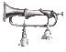U.S. CAVALRY BUGLE SIGNALS

General Notes:

Posts of the Officers and Non-Commissioned Officers of the Field and Staff of a Regiment in order of battle. The Colonel 25 paces in front of the center of the regiment; having a chief bugler behind him. The Trumpeters, formed in two ranks are posted 25 paces in rear of the center of the regiment. The Trumpeters of a squadron acting separately, are posted in the same manner, but in one rank. First Part, P. 4 (Pl. 1)

Posts of Officers and Non-Commissioned Officers of a Company acting singly. The Buglers 20 paces in rear of the center. First Part, P. 7

Formation of the Escort of the Standard. The 1st platoon of the escort furnishes the advance guard, composed of two men in front with the carbine advanced or pistol raised. A Corporal and four men with drawn sabres (or lances at a carry) march 10 paces from

them. The Trumpeters, formed by fours and conducted by the Adjutant, march 10 paces from the four men who precede. First Part, P. 9

Reception of the Standard. See page 1, #7 - March

Pass in Review. At this command the band and trumpeters repair to the head of the regimental column, 6 paces in front of the Colonel. First Part, P. 20

Form and Course of Inspection. The trumpeters of each company take post on the alignment of the front rank, 6 paces from the right. First Part, P. 23

Division, Order And Progression of Instructions. The horses of the Orderly Sergeants, and Trumpeters, cannot be excused on any pretext from participating in the different classes of instruction. First Part, P. 28

Soundings. Are the trumpet signals, which make known to the troop the movements or details of service which are to be executed. First Part, P. 81

9

U.S. CAVALRY BUGLE SIGNALS

THE BUGLE SIGNALS FOR A TYPICAL DAY

5:45 AM Assembly of Buglers "First Call," Awakens troops
6:00 | Assembly (for Roll Call)
6:15 | Reveille (as soon as Reveille ends the Roll Call count begins)
At sunrise |  | To the Standard (Flag Raising Ceremony at Headquarters)
6:30 | Stable Call
7:00 | Breakfast
7:30 | Sick Call (sounded after every meal)
7:45 | Officers Call
8:00 | Watering Call
8:15 | Orders (Sergeants turn in the Daily Report)
8:30 | Fatigue Call (report for work detail)
9:00 | Assembly of Guard (changing of the guard every 24 hours)
9:30 | Boots & Saddles
9:45 | To Horse
10:00 | Drill Call
12:00 PM |  | Recall (dismissal from drill and Fatigue duty)
12:30 | Dinner call
1:00 | Sick Call
1:15 | Distributions
1:30 | Officers Call
1:45 | Boots & Saddles
2:00 | To Horse
2:15 | To The Standard (not needed unless formal parade or going into battle)
2:30 | Drill Call or March, going into battle
4:30 | Recall (dismissal from drill, return to camp)
4:45 | Stable Call
5:00 | Watering Call
5:30 | Dinner
At sunset |  | Retreat (long version, lowering of flag)
8:30 | Tattoo, the Trio Return to quarters
9:00 | Tattoo (to extinguish lights)
9:15 | Taps (After 1862 in Eastern Theatre & after Winter 1863 Western Theatre)

10

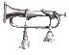U.S. CAVALRY BUGLE SIGNAL DITTIES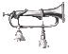

{to aid in memorization of the bugle signals}

NO. 1 THE GENERAL:

Time to get up and marching, time to get up and onward, time to get all your kit and gear packed. Time to get up and marching, time to get up and onward, time to get all your kit and gear packed. Time to trot today, we're packing and moving and time to trot to day we're breaking our camp. Time to trot today, we're packing and moving and breaking our camp, Gen-er-al says, Let's Go Right Now. To Your Horse and Move! To Your Horse and Move!

NO. 2 BOOTS & SADDLES

Go to your hor-ses Bridle and saddle 'em up. Surcingles, cinchas on them all.

NO. 3 TO HORSE

Go to the picket line and get your horse,
You are to find him where'er he may be of course
(or)
Go to your Number 4 and get your horse.
You are to find him where'er he may be of course.

NO. 4 THE ASSEMBLY

Time to fall into ranks, time to stop your foolish pranks,
Get in line, markin' time, till the end of your days.

NO. 5 TO ARMS

To Arms! Men, to Arms! Go get your guns, its time to hunt some Rebs,
Let's trot around and shoot 'em down, E-lim-in-ate the Se-cesh.
Traitors to our glorious Flag, let's kill them one and all.

NO. 8 THE CHARGE

Gal-lop boys with your sabers, with your sabers, for the Charge.

NO. 11 STABLE CALL

Come to the stable as soon as you're able, and groom off your horses and give them some corn.
For if you don't do it, the Captain will know it,
and then you will rue it, as sure as you're born.
So, come to the stable as soon as you’re able,
and groom off your horses and feed them some corn.

11

U.S. CAVALRY BUGLE SIGNAL DITTIES

NO. 12 WATERING CALL

Time to get Wa-Ter for your horses, Now!

NO. 13 BREAKFAST

Soupy, soupy, soupy, without a single bean,
Coffee, coffee, coffee, without any cream,
Porky, porky, porky, with nary any lean.

NO. 14 ASSEMBLY OF GUARD

Time to be posting and mounting the guard for the day,
Time to be posting and mounting the guard for the day,
Time to be posting and mounting the guard for the day,
Time to be posting and mounting the guard!

NO. 15 ORDERS

Time to get Orders now,
Time to get Orders now,
Time to get Orders now!

NO. 17 RETREAT

Time to re- TREAT! We can not be Beat,
but march A-way, we'll fight again some day,
but for now, we'll have to save our ___.

NO. 18 FATIGUE CALL

Come on and shovel it up, join in the fun (3 times).

NO. 20 DISTRIBUTIONS

Go to the Adjutant, boys, time for your pay!
Go to the Adjutant, time for your pay!

NO. 21 DRILL CALL

To the left, to the right, fall in line, dress your ranks, I'm getting tired of this To the left, to the right, till the end of your days, I'm getting real sick of this!

NO. 22 OFFICER'S CALL Ah-Ah-Fi-Cers Call, Ah-Fi-Cers Call, Ah-Fi-Cers Call Ah-Ah-Fi-Cers Call, Ah-Fi-Cers Call on the run.

NO. 24 CEASE FIRING

C-ease Fire! C-ease Fire! C-ease Fire!

NO. 25 OFFICER'S TAKE PLACE

Officer! Officer! Officers! Form.

12

U.S. CAVALRY BUGLE SIGNAL DITTIES

NO. 26 SICK CALL

Call for the sick, call for the dead.
Now it's time to form up in a line.
Call for the sick, call for the dead.
Now it's time to march on as it's off to bed we go.

NO. 27 TATTOO

Gen tle men it's time to Ex Ting guish lights,
snuff out your lamps and go to sleep!
Gen tle men it's time to Ex Ting guish lights,
snuff out your lamps and go to sleep.

RECALL (Infantry)

Come back here now, come back here now.
Co-ome, Co- ome, Co- ome back here now. (repeat one time)

Quick March (The American Flag)

Stanza 1

A-s we were marching u-p a hill, my heart did stir at the si-ght,

of our flag so bold in Red White and Blue, that will lead us straight into the fight!

Three cheers, my Boys and give us a shout, Cheer for the Stars and the Stripes Three cheers, my Boys and a mighty Hurrah, for it's the A-mer-i-can Flag

Stanza 2

A-s we were marching do-own the street, by chance did I es-py-y
Was a sight so True in Red, White and Blue, wa-ving high up in the sky!

Three Cheers my Boys and give us a shout, Cheer for the Stars and the Stripes Three Cheers my Boys and a mighty Hurrah! For It's the A-mer-i-can Flag

As sounded on solo field trumpet (in G) by R. J. Samp, 2nd Wisconsin Volunteer Infantry

13

U.S. CAVALRY BUGLE SIGNAL DITTIES

FOR THE SERVICE OF SKIRMISHERS

NO. 1 FORWARD

We're Ma-ar-ching Forward! and moving ahead
We're Ma-ar-ching Forward! and moving ahead.

NO. 2 HALT

Time to Halt! Stand fast men.

NO. 3 TO THE LEFT

To the Left.

NO. 4 TO THE RIGHT

Turn-ing To The Right.

NO. 5 ABOUT

Turn ing around, turning around, turning around, boys!

NO. 6 RALLY ON CHIEF

Rally Boys!, Rally Boys!, Forming up on the Chief Rally Boys!, Rally Boys!, Forming up on the Chief.

NO. 7 TROT

[A syncopated rhythm on the same note (E)]

NO. 8 GALLOP

Galloping, Galloping, Galloping.

NO. 9 COMMENCE FIRING

[Oh] Keep up the Fi-re, Keep up the Fi-re, Keep up the Fi-re Boys.

NO. 10 DISPERSE

Time to spread out and fight b-oys, spread it a-round and Fight like Hell

Time to spread out and fight b-oys, spread out and Fight like Hell.

14

U.S. CAVALRY BUGLE SIGNALS

NO. 1 THE GENRAL
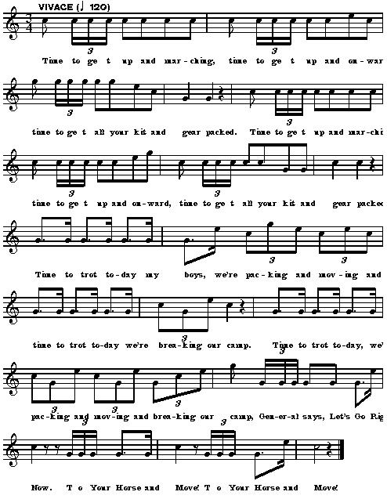

15

U.S. CAVALRY BUGLE SIGNALS

NO. 2 BOOTS & SADDLES
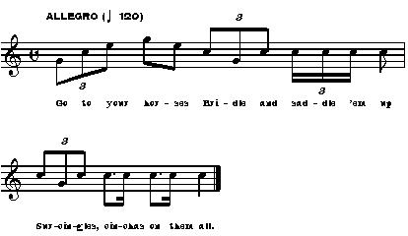

NO. 3 TO HORSE
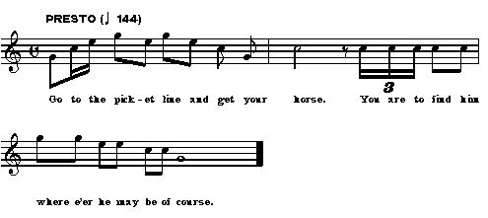

16

U.S. CAVALRY BUGLE SIGNALS

NO. 4 THE ASSEMBLY
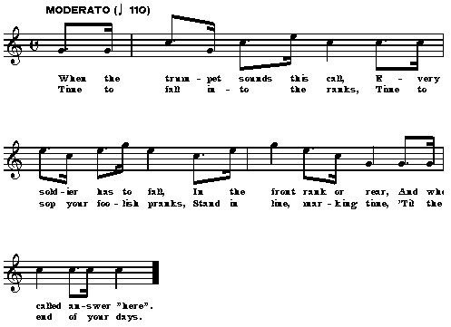

NO. 5 TO ARMS
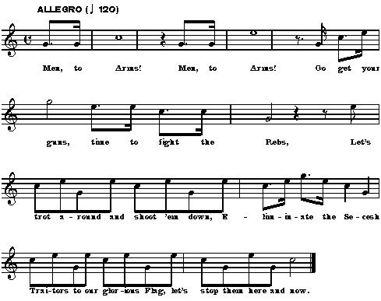

17

U.S. CAVALRY BUGLE SIGNALS

NO. 8 THE CHARGE
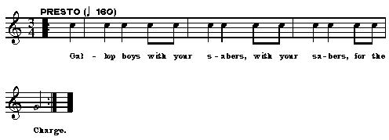
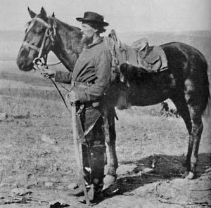

18

U.S. CAVALRY BUGLE SIGNALS

NO. 11 STABLE CALL
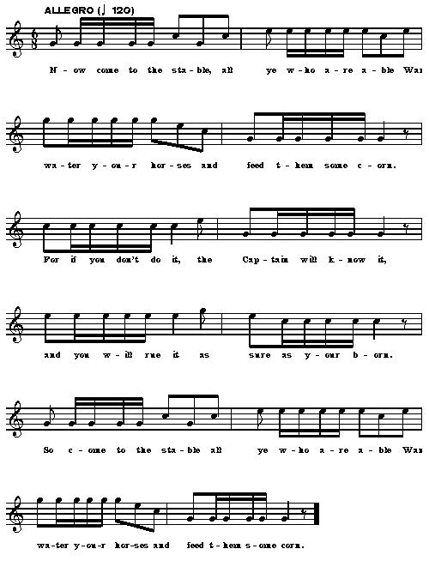

19
U.S. CAVALRY BUGLE SIGNALS

NO. 12 WATERING CALL
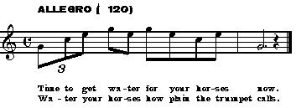

NO. 13 BREAKFAST
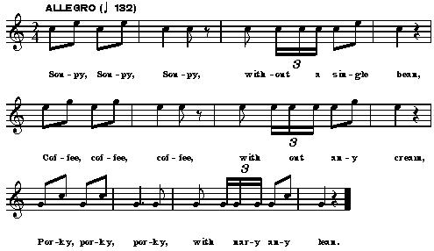

20

U.S. CAVALRY BUGLE SIGNALS

NO. 14 ASSEMBLY OF GUARD
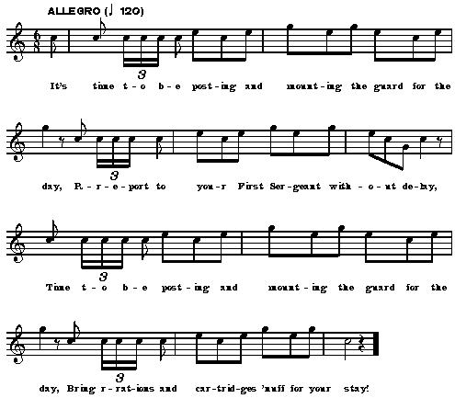

NO. 15 ORDERS
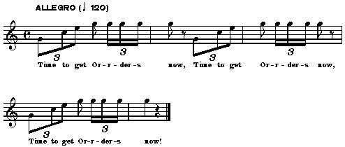

21

U.S. CAVALRY BUGLE SIGNALS

NO. 17 RETREAT
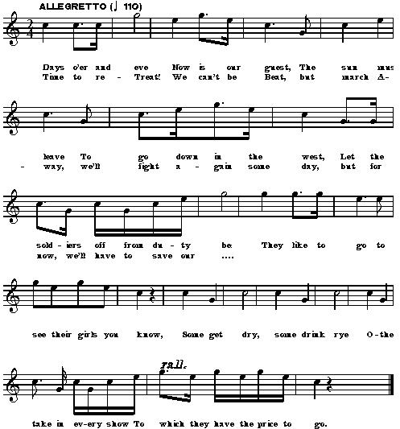

22

U.S. CAVALRY BUGLE SIGNALS

NO. 18 FATIGUE CALL
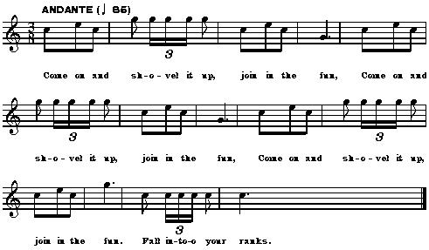

NO. 20 DISTRIBUTIONS
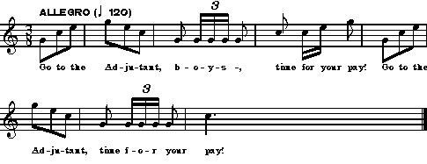

23

U.S. CAVALRY BUGLE SIGNALS

NO. 21 DRILL CALL
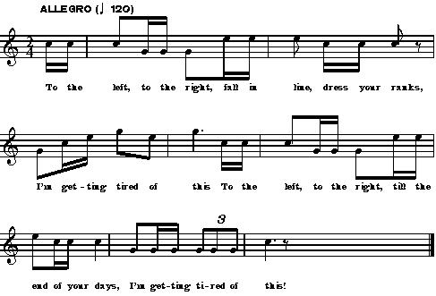

NO. 22 OFFICER’S CALL
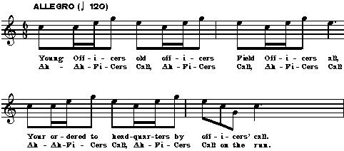

NO. 24 CEASE FIRE
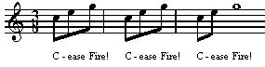

24

U.S. CAVALRY BUGLE SIGNALS

NO. 25 OFFICER’S TAKE PLACE
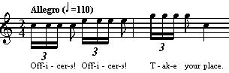

NO. 26 SICK CALL
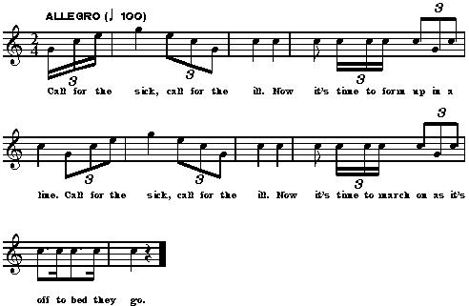

NO. 27 TATTOO
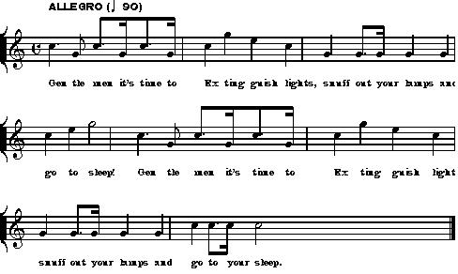

25

U.S. CAVALRY BUGLE SIGNALS

NO. 23 THE RECALL
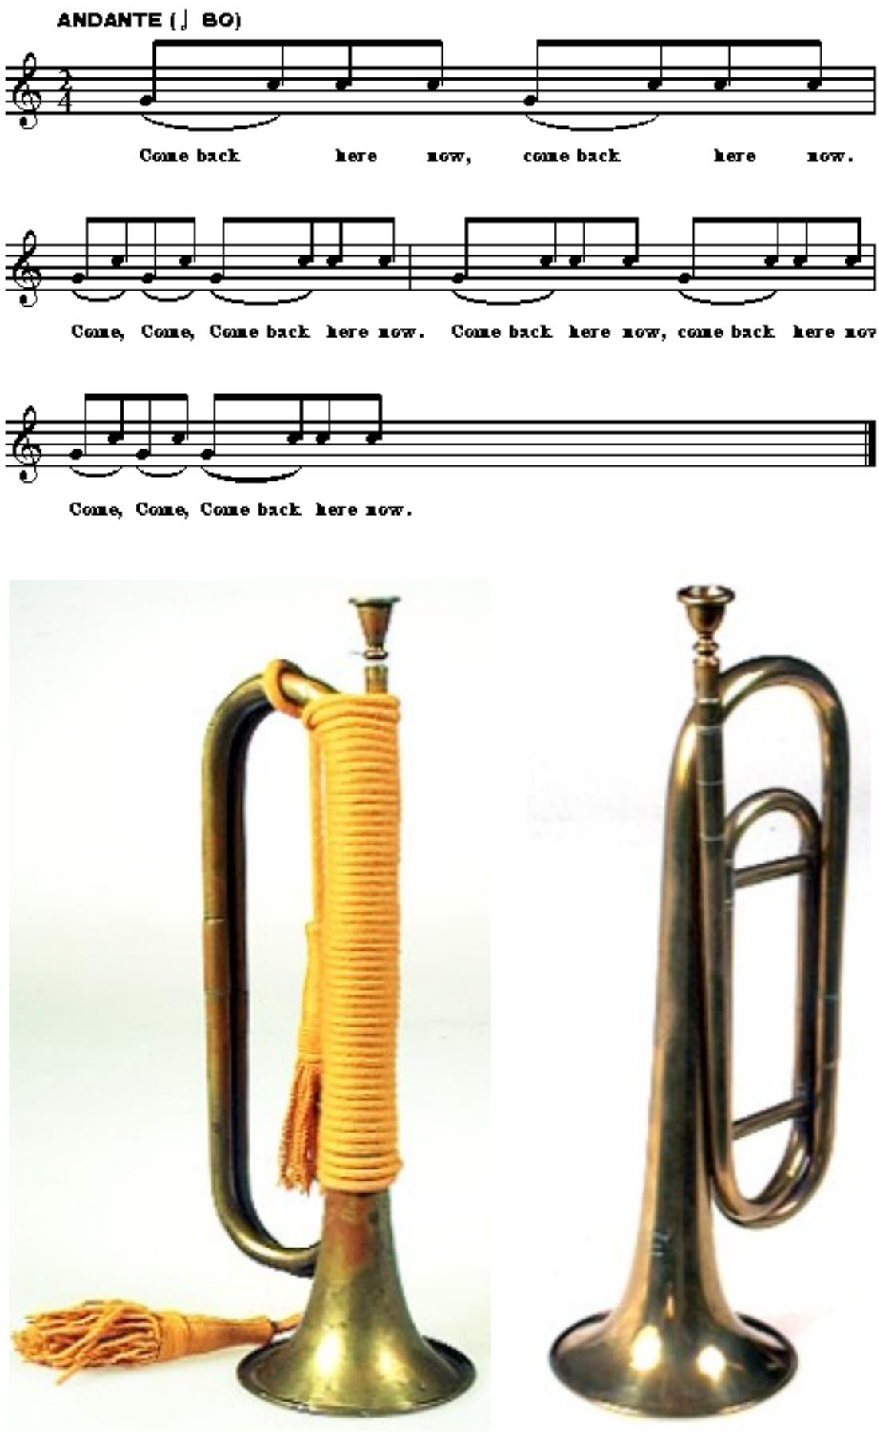

26

U.S. CAVALRY BUGLE SIGNALS
For the Service Of Skirmishers

NO. 1 FORWARD
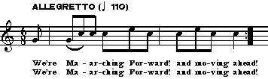

NO. 2 HALT
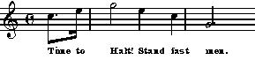

NO. 3 TO THE LEFT
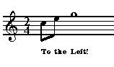

NO. 4 TO THE RIGHT
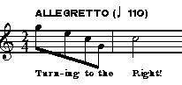

NO. 5 ABOUT
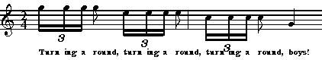

27

U.S. CAVALRY BUGLE SIGNALS
For the Service Of Skirmishers

NO. 6 RALLY ON CHIEF
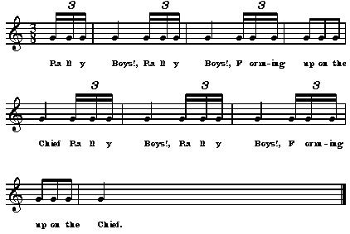

NO. 7 TROT
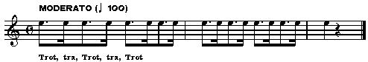

NO. 8 GALLOP
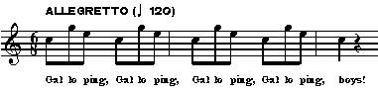

28

U.S. CAVALRY BUGLE SIGNALS
For the Service Of Skirmishers

NO. 9 COMMENCE FIRING
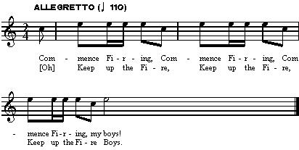

NO. 10 DISPERSE
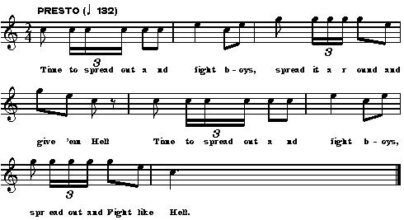

29

I wish to acknowledge the assistance of R J. Samp, Chief Bugler-Federal Forces at Gettysburg135, and Trooper Tim Short, Bugler, First NH Cavalry for their assistance in preparing this work. A tape of the bugle signals accompanies this work.

Author/Cavalry Researcher Editor/Bugling Researcher

Capt. R D. Lynch, First NH Cavalry RJ Samp, 2nd WVI

46 Highland Ave. Three Danada Square East, Suite 173

Jaffery, NH 03452 Wheaton, IL 60187

A Trooper’s Friend

My friend and I rode off to war, When country and duty called;

We fought four long and bitter years… By glory unenthralled.

I loved him dearer than a brother, More than tongue can tell;

And though he never spoke a word… He loved me just as well.

Though we both were often hungry,

If there was grain, it went to him;

I knew I would get by on salt pork, And on moldy hardtack grim.

A bursting shell at Chickamauga, Took one of his ears away…

But he stood outside the surgeon’s tent, As they cut lead from me that day.

He saved my life at Brice’s Crossroads, And took a bullet meant for me;

A saber slashed across his neck, When we charged some battery.

And now here in Alabama, The end is drawing near…

Dark smoke and bloody hoof prints, Across the land and cause so dear.

My friend did not arise this morning,
And though he tried to lift his head…

I saw within his silent eyes,
There were lonely roads ahead.

The captain rode up beside us,

And said “Ben we must retire.”
His next order died unspoken…
He knew the shot I’d never fire.

I knelt beside my friend and stroked his mane,

As the column rode away;

I gave him water from my canteen, And kept the flies at bay.

He struggled once more to gain his feet, And he seemed to say, “We tried!”,

I could not see him for my tears… And I held him as he died.

With only cup and saber,

I mounded him with clay…

For such a true and faithful friend, I could not leave for vulture prey

He’s galloped beyond war’s flame and fury, Past the battle smoke and din,

If there are horses up in Heaven… May we ride together again.

Sgt. Benjamin R. Gormley

Georgia Division Cavalry

March 21, 1990

30

